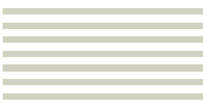



*Toad Data Modeler Guide by John Cusey*

*January 13, 2019*



# Introduction

https://www.quest.com/products/toad-data-modeler/

Easily create high-quality data models. Toad Data Modeler enables you to rapidly deploy accurate changes to data structures across more than 20 different platforms. It allows you to construct logical and physical data models, compare and synchronize models, quickly generate complex SQL/DDL, create and modify scripts, as well as reverse and forward engineer both databases and data warehouse systems. Toad's data modeling software simplifies database design, maintenance, and documentation.

# Setting up Project

## How to create a project

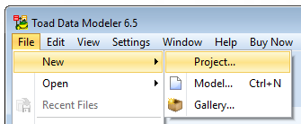

Creating a New Project

A project is a container that holds all of your physical elements like entities, relationships, and views. When you create a new model, then you’ll see the Physical Model Explorer appear at the vertical left-hand-side of this tool.

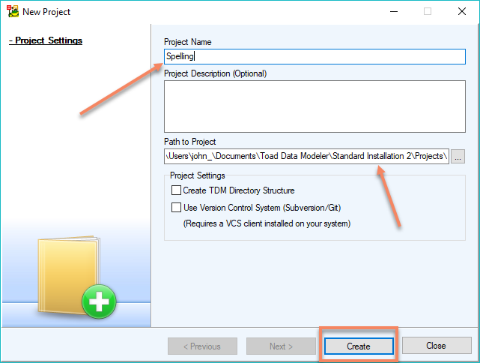

Assign Project Name

When creating a new project, you will have to specify the project name, the path to the project and project settings. In the project path, you’ll notice part of the path I have a “standard insulation 2” this is because I initially installed the wrong version of TDM and had to reinstall the software. The freeware version of TDM is 6.5.5.

**C:\Users\john_\Documents\Toad Data Modeler\Standard Installation 2\Projects\**

**How to create a model**

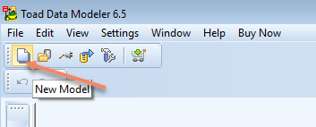

Creating a New Model

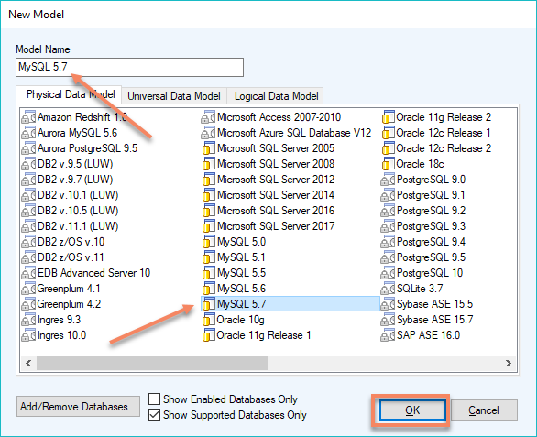

Assigning a model name and database type

**Adding an Entities**

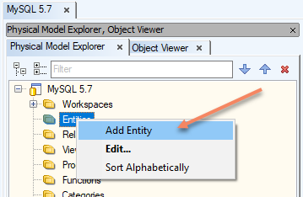

Adding Entity

***Right click*** on theEntities Folder in the Physical Model Explorer to select the ***add entity*** option.

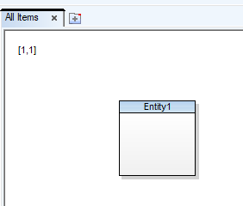

Empty entity

An empty entity will appear in your workspace. You have to ***double click*** the entity to open the Entity Property dialog box so you can assign the entity a name and add attributes.

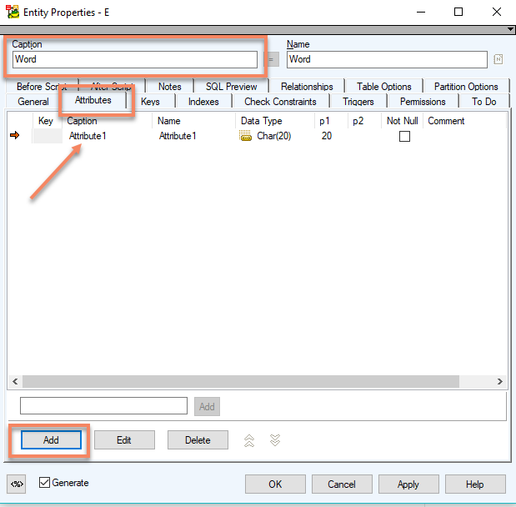

Assign Entity Properties

I typed in the ***Caption Box*** to assign ***“Word”*** as the name of this entity. Then clicked on the ***Attribute Tab*** to show the Attribute Table. Just click on the ***Add Button*** at the bottom of the dialog box to add an entity to the Entity Table.

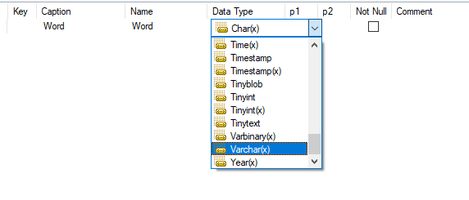

Changing attributes

Just single click on the Attribute Row in the table you want a change that row.

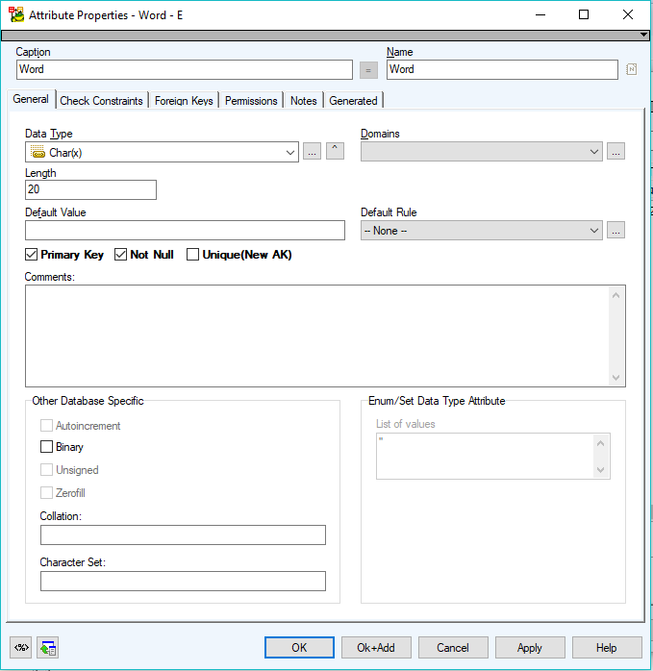

Double click open Attribute Properties

You can ***double click*** on the Attribute Row to open up the Attribute Properties Dialog Box to set this row is the Primary Key.

**Exporting and Importing Files**

To start exporting and importing files with Toad Data Modeler, you have to go to the main menu and select ***Files → Import to Import*** a File or ***Files → Export to Export*** a File.